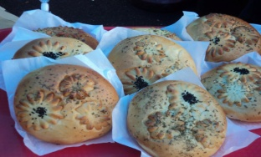
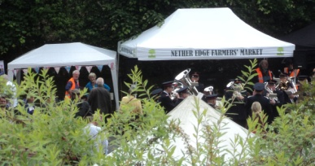
NETHER EDGE FARMERS’ MARKET
Sunday 13th September 2020 12noon – 4pm
With over 40 hot & cold food stalls, craft stalls and live band music
To help comply with Covid-19 restrictions, please note:
- DON'T COME if you have any symptoms of the Covid-19 virus
- We are expecting all adults and teenagers to wear a face covering unless you have a reason not to
- Think of others and keep your distance as much as possible;
- There are fewer stalls this time so more space than usual. Please use it!
- We'll have marshals trying to make sure the area doesn't get too crowded - listen to them and cooperate
- At busy times we might have to have a one-in-one-out system
- Please leave your dog at home.
- Toilet space will be very limited so please ‘go’ before you come
- Don't touch anything on a stall without asking the stallholder - they will probably ask you to use hand sanitizer first
- Stallholders are encouraged to accept card payments only - but best bring some cash as well for the smaller stalls. ,
MARKET DAY ROAD CLOSURES
Nether Edge Rd & Glen Rd will be closed to traffic from 9am - 5pm. Please avoid parking on these roads the night before.
For traders, we will be operating a one-way system before and after the market.

MARKET BENEFICIARIES
Proceeds from the market will be divided between: Chelsea Park playground appeal & Flourish (a mental health charity)

HELP: Offers of help on market days (especially marshalling due to Covid-19 restrictions) are always appreciated.
Contact David 281 9414 or email davidpierce96@icloud.com

Our next NETHER EDGE FARMERS’ MARKET will be on 29th November 2020 from 11am – 3pm (Note earlier times)
To book a stall at our Xmas market, please email nengfarmersmarket@gmail.com or see www.netheredge.org.uk

